Mini Wonders

Summary
Contacts
Overview
Objectives
Relationship to Existing Systems
Terminology
Feature Details
Overview
Unlocking Mini Wonders
Event Flow
Registration Period
Fight Period
Wonder Forest
Protected Period
Seasons/Series
Mini Wonder Map
Edge Cases
Rewards
Crate Contents:
Season Rewards:
Realm Advancement
UI
Event Page
Rewards Page
Rules Page
Registration
Control
Seasons
Rewards
Season Rewards
Information Page
Access
Fight Rewards
Season Rewards
Guild Ranking
Rules
Fortresses Page
Radial Menu
Sales
Implementation Details
Push Notifications
Tutorial
Mail
BI
Performance
Art
Audio
Design Data
Event Quest Hooks
Go-Tos
Feature Gates
Live Ops
Debug Commands & Presets
CS Tools
Benching
Internal Mini Wonder Informational Resources
- MapObjectPlacement.xlsx (ffane)<- Wonder and Mini Wonder Footprints
Mini Wonder informational Resources
Outstanding Items

Summary
Any images used from other games are purely for market research purposes only.

Contacts
- Designer(s): Jordan Gruenert
- UI/UX: Andrew - WONDER UIUX CONFLUENCE LINK
- RML: TBD
- Engineer(s): TBD

Overview
- Have Wonder experiences that allow smaller guilds to compete over meaningful objectives.
  - Guilds fight over 1 small and 1 medium wonder
- Maintain a ‘Season’ where you get more points depending on the objectives you control over a long period of time.

Objectives
- Allow small and mid size guilds to experience wonder combat and earn rewards based on persistent success.

Relationship to Existing Systems
- These would look like wonders but have a different event related to them.
- This should utilize the MapObjectPlacementData for setting up the footprints and wonder locations.

Terminology
Ideas:
- Wonder Naming:
  - Grand Throne (Main Wonder) = Capital
  - Major Stronghold (Medium Wonder) = Fortified Facility
  - Minor Stronghold ( Small Wonder) = Fortified Bunker
  - Stronghold Siege (for both the minor/major strongholds) = Fortress Fight
- Season/Mini Wonder Season Naming:
  - Option 1:
    - Season: Season
    - Mini Wonder Season: Series/Bout/Cycle
    - Mini Wonder Rounds/weeks: Round/Period
  - Option 2:
    - Season: Era
    - Mini Wonder Season: Season
    - Mini Wonder Rounds/weeks: Round/Period

Feature Details
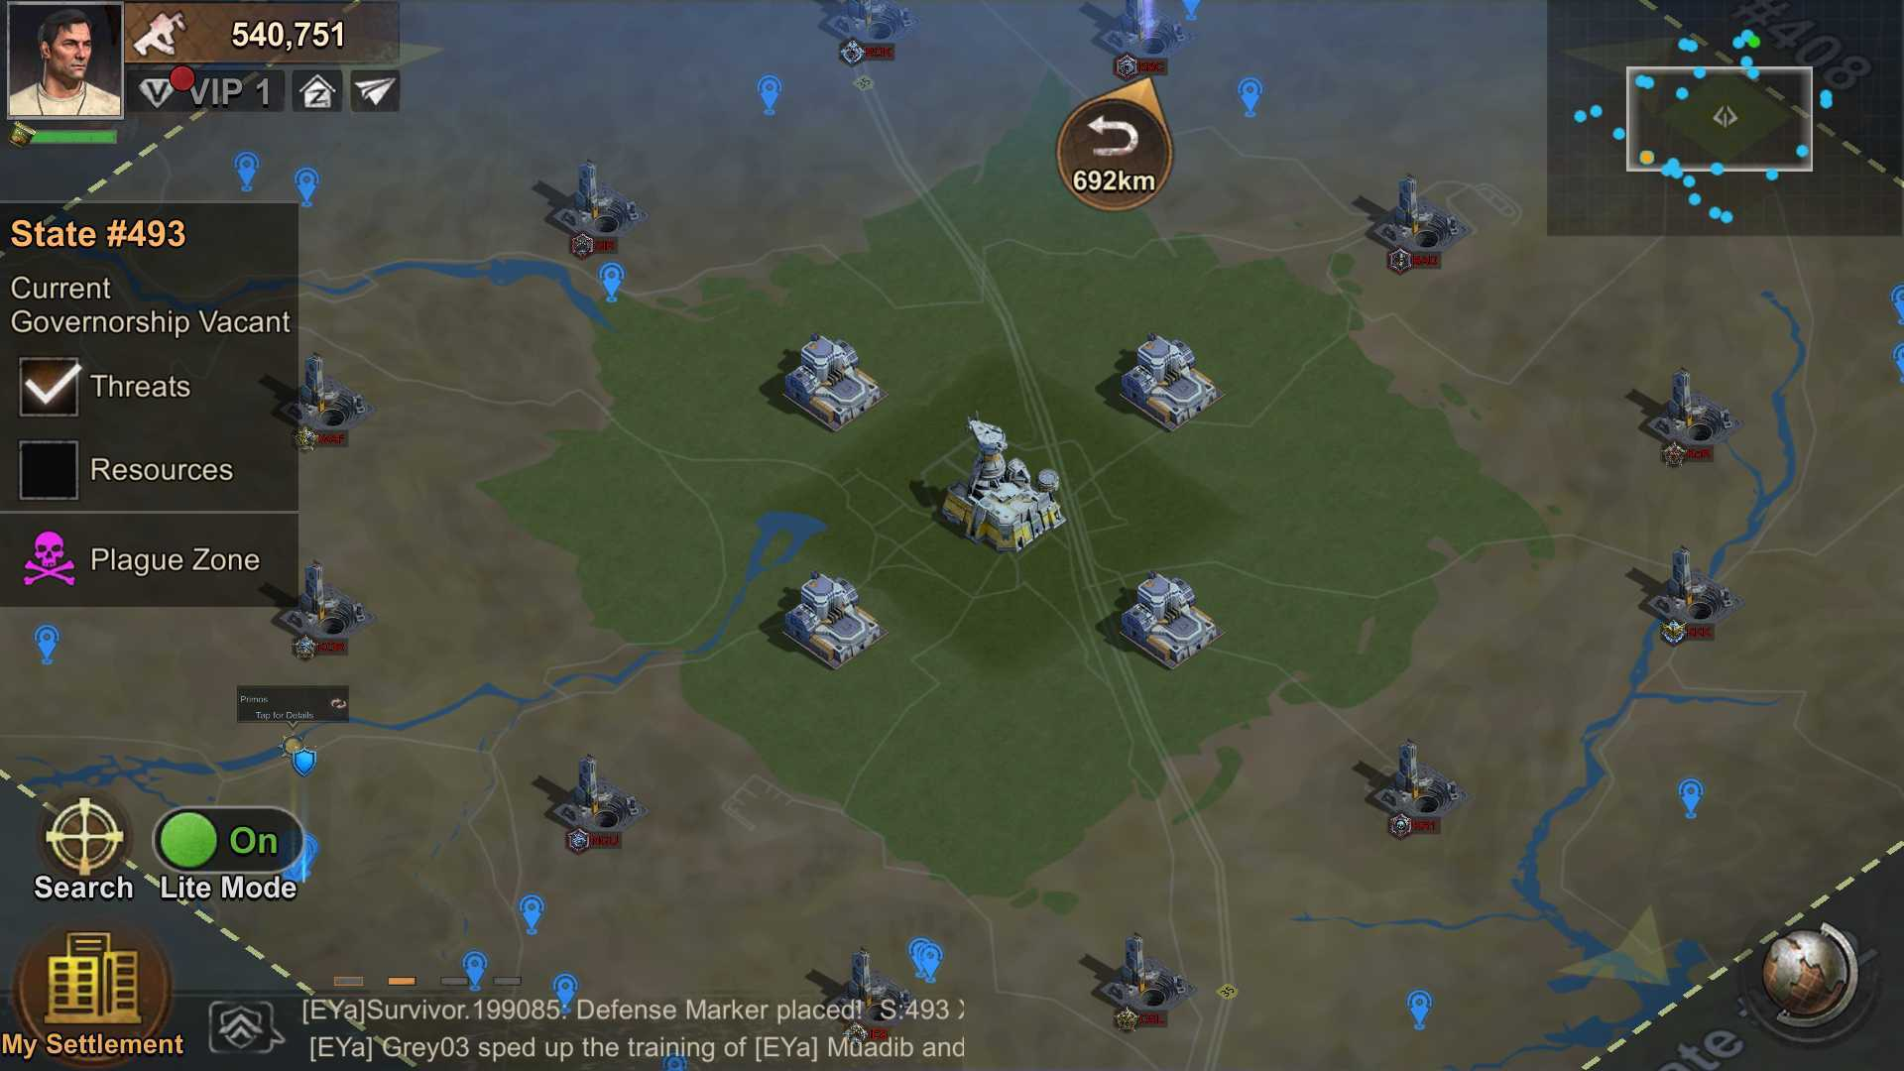

Overview

Unlocking Mini Wonders
- Guilds will be able to challenge Mini Wonders once the realm completes the associated Realm Advancement
  - Will grant a named bonus that will be required to challenge the Mini Wonder

Event Flow
- Weekly Cadence:
  - Every week
  - Weekly Schedule
  - Break Weeks:
    - End of the Season there is a break week we assume. Will check back in 3 weeks when the season is over.
    - Fortress Fight DOES happen on the same week as Capital Clash

Registration Period
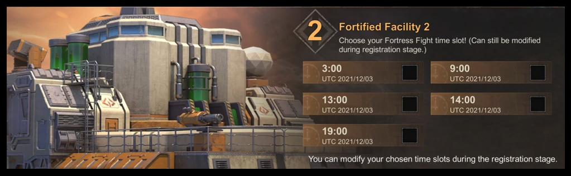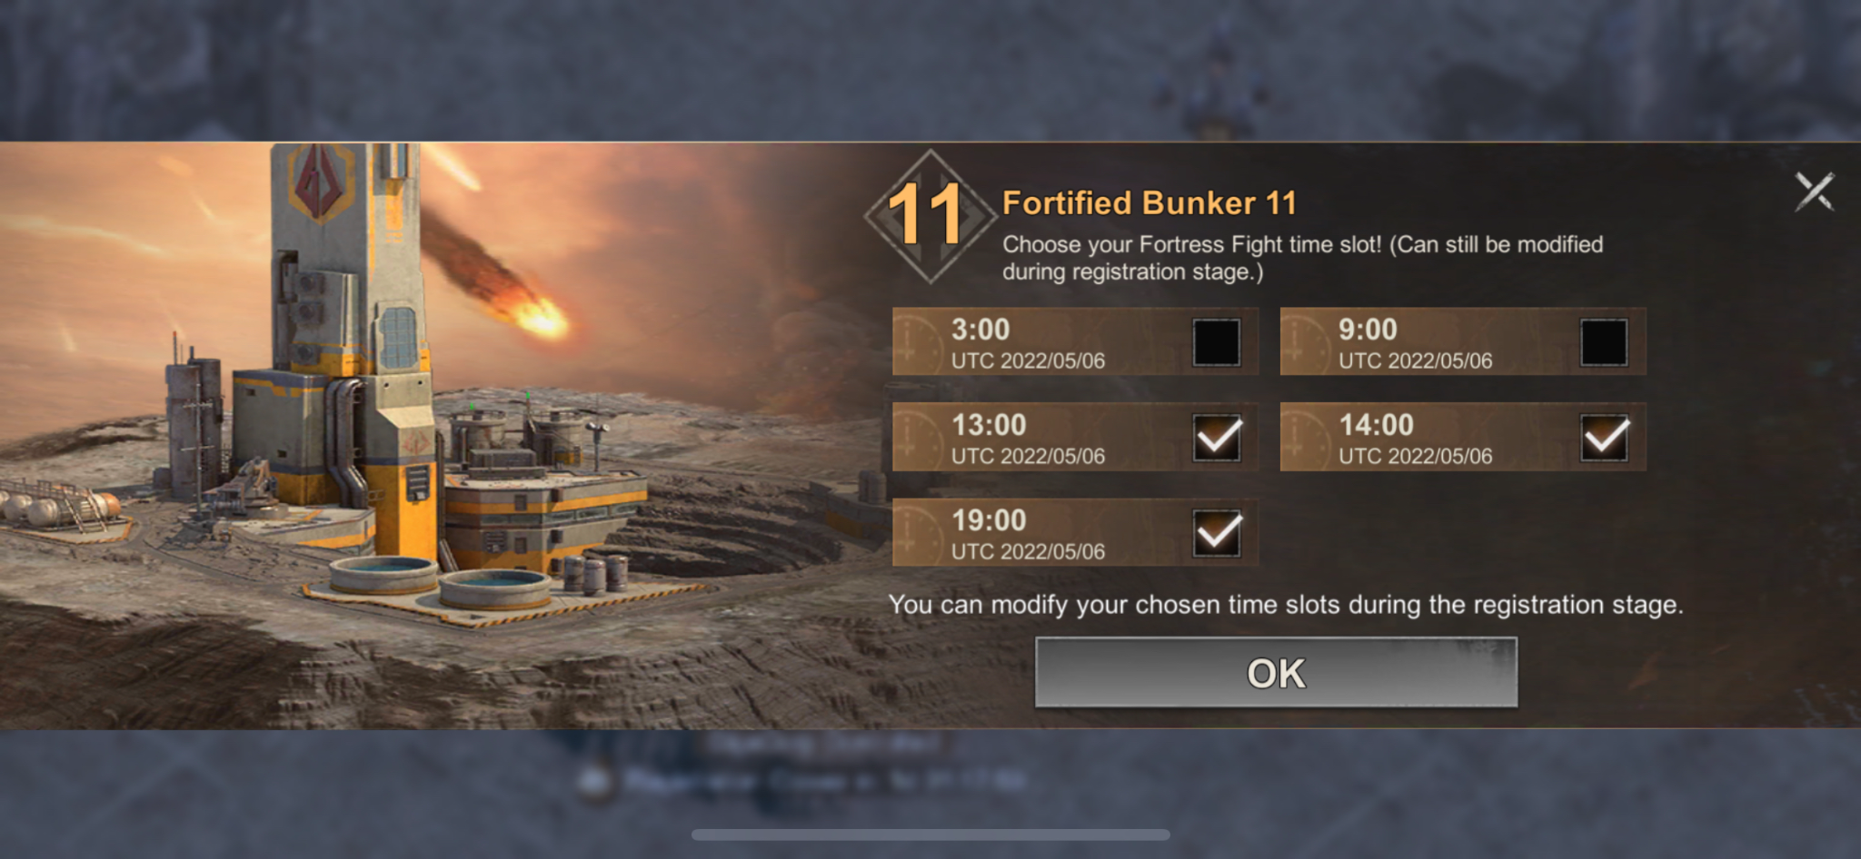
- At the beginning of every round, the R5 and R4 can choose 1 Stronghold and 1 Fortress to sign up for (New Register).
  - If the Guild successfully controls a Mini Wonder from the previous round, they are automatically enrolled to participate in the one they won and gain the ability to register for an additional Stronghold and Fortress.
    - Example: A guild won Stronghold A and Fortress X, so they can now sign up for Stronghold B and Fortress Y and will be competing over 4 targets in the 2nd Round of the Season.
    - These cannot be unselected or selected for the purpose of a new registration.
  - Selecting a New Register when one is already selected, swap the selection.
- There are 16 fortresses in total, 12 Fortresses and 4 Strongholds
- During registration, Guilds can choose 3 time slots (from 5) to challenge for the Fortress.
  - Time Slots (in UTC)
    - 0:00 - 2:00
    - 6:00 - 8:00
    - 12:00 - 14:00
    - 15:00 - 17:00
    - 20:00 - 22:00
- Each fortress gets fought over once per round/week in one of the above timeslots.
- The timeslot selected for the fortress fight is the slot most selected for that fortress.
- If two time slots have an equal number of the most votes, one slot with the most votes is chosen at random.
- An Alliance can only register for a mini wonder when they reach alliance level 4
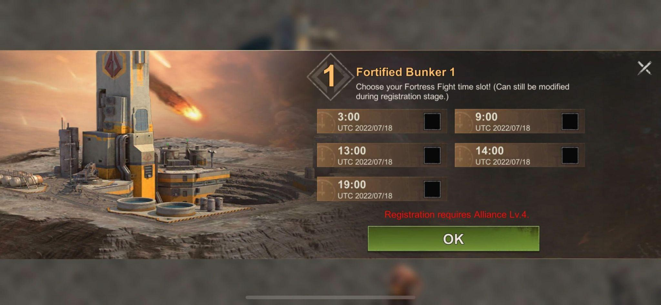
- An unlimited number of alliances can register for the same fortress to fight over it.
- All alliances that have registered for a specific fortress will fight at the selected time slot even if it wasn’t a time slot they chose.
- If an alliance selects a fortress no one else has registered for, they get to fight the PVE and take the fortress with no contention. Free Fortress.
- We will not enforce Guilds being registered to any Mini Wonders or time slots. If they miss the opportunity to sign up, they just miss out on the opportunity to earn points.
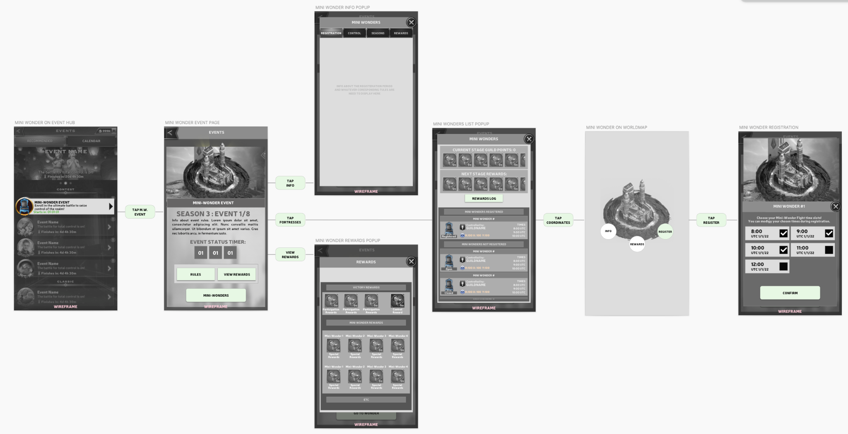

Registration Screens Phases:
Mini Wonder Registration Menu States
- Registration phase - Not Registered
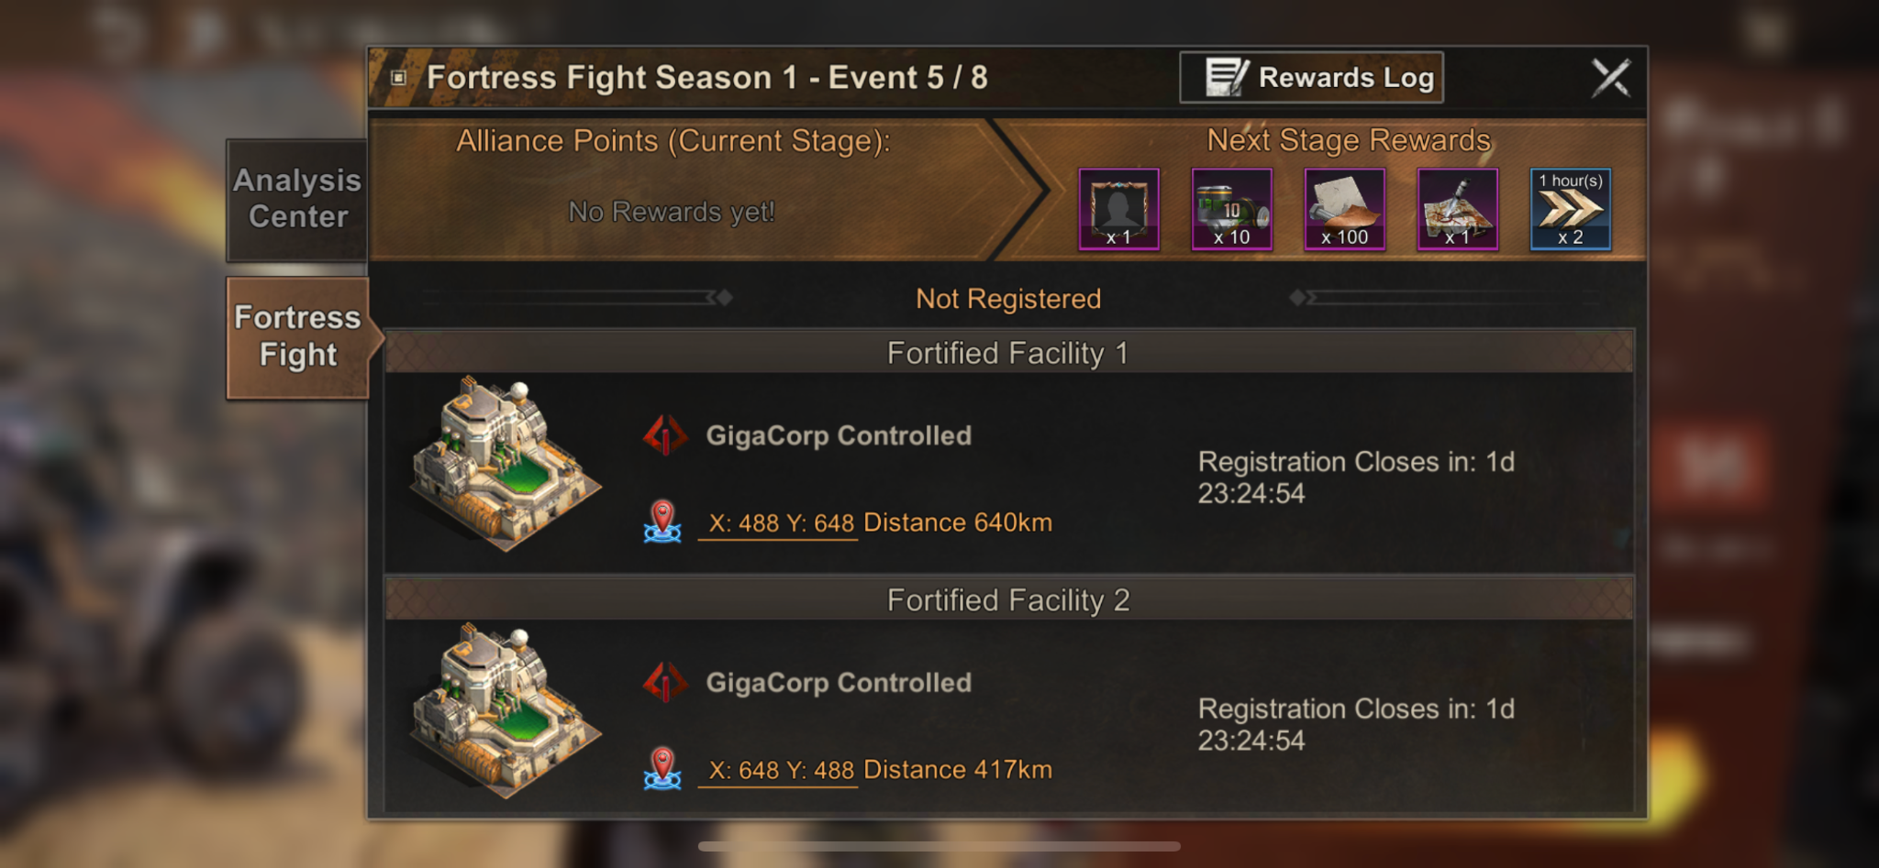
- Registration phase - Registered
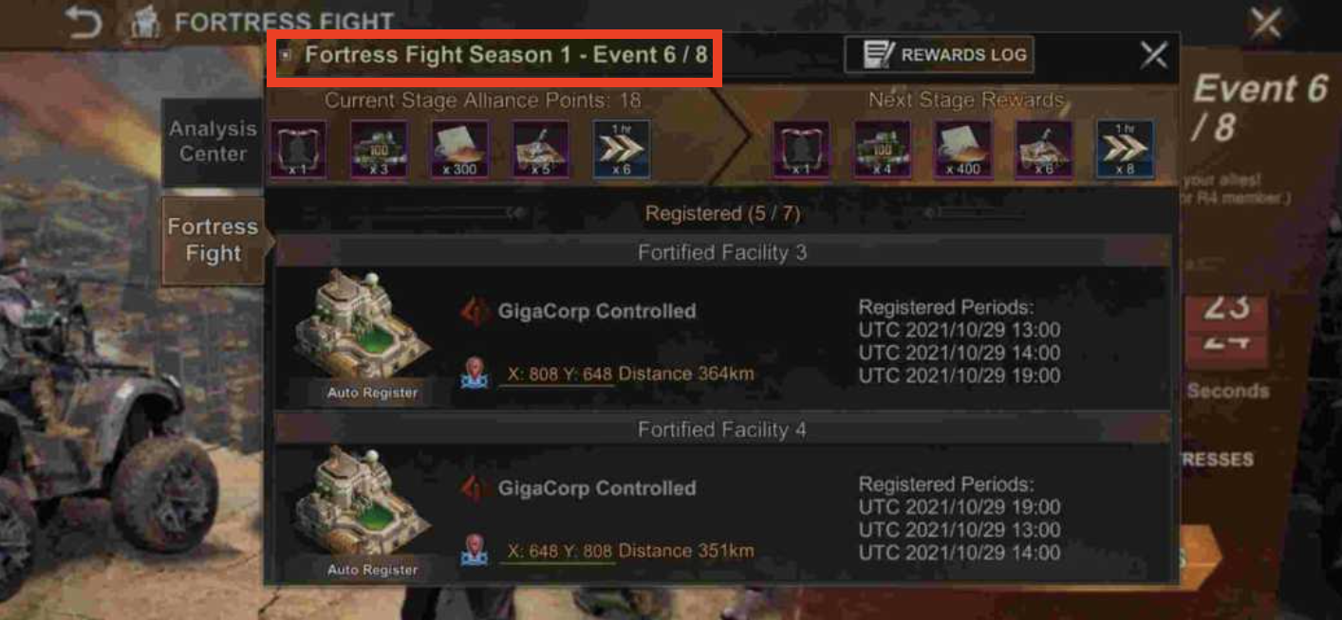
- Fight phase
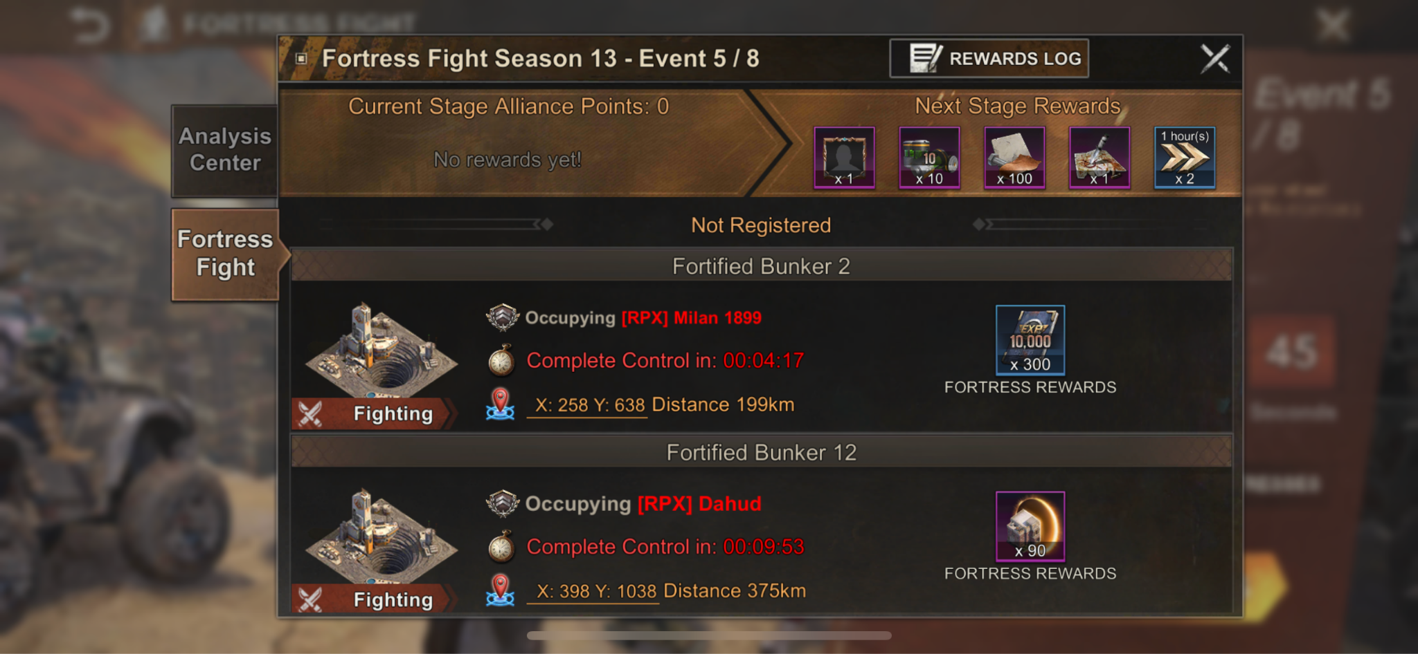
- Rewards Phase
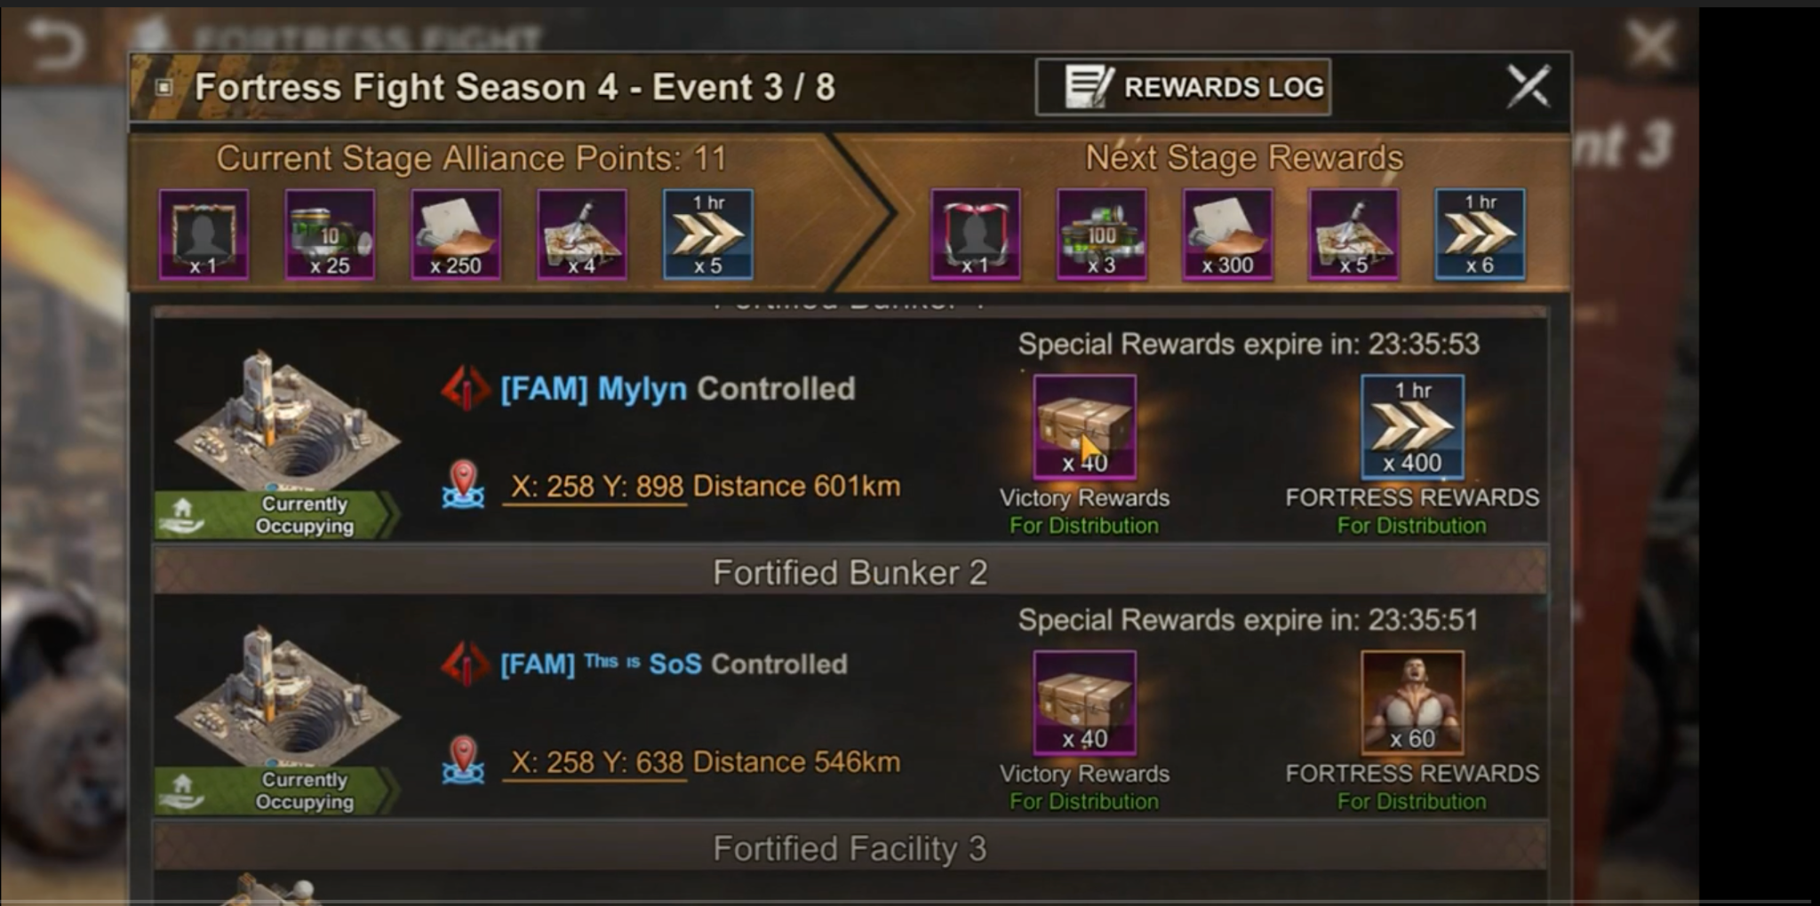

Fight Period
- Once the registration period ends, begin the first fight period.
- Guild Members can Rally/March/Reinforce Mini Wonders they are registered for if the current fight period is a time slot they signed up for.
  - Combat functions like Main Wonder Combat today but with a set list of guilds that can actually attack each structure and a PVE Defender that needs to be cleared out before the PVP stage begins.
    - Handle the error case of trying to attack a mini wonder you arent registered for.
    - Handle the error case of trying to attack a mini wonder you are registered for but aren’t set for the specific time slot.
- The Fight Period refreshes the PVE enemy defending the Mini Wonder.
  - Defeating the PVE enemies will produce a reward for the entire Guild and they will take the first control over the wonder.
- During the 2-hour Time Slot, a Guild can take Control of the Mini Wonder by occupying them for 30 minutes continuously.
- If no Guild manages to occupy the Fortress for a continuous 30 minutes, the Guild that occupies the Fortress when the time slot finishes will take Control.
  - When a guild gets to the 30 minute mark, the wonder becomes protected and closes.
- Controlling/Winning a Mini Wonder provides points for the guild for the season.
  - Fortresses provide 1 point
  - Strongholds provide 2 points
- In combat at Fortresses, all the participants are counted as the defending side of the hospital wounded distribution table. (Troops only get wounded but won’t die as long as the hospital capacity is enough)
  - Note: This could be a different entry, the point is that the wounded/killed ratio is low.
- In combat at Strongholds, all the participants are counted as the attacking side of the hospital wounded distribution table
  - Note: This could be a different entry, the point is that the wounded/killed ratio will be higher than the Fortresses
- Once the fight period has concluded, all occupying units and incoming marches will return to their home cities and begin a Protected Period.

FFANE Combat - Mini Wonder/Wonder Doc

Wonder Forest
Similar to the Main Wonder, Mini-Wonders will be surrounded by a Wonder Forest (Scarred Lands) that slows marches and randomly teleports players whose cities are defeated within its borders.

Protected Period
- The mini wonders are always protected and only become unprotected during their single registered fight period each week.

Seasons/Series
- Alliances accumulate points for capturing a Fortress:
  - 2 for Stronghold
  - 1 for Fortress
- The points an Alliance earns each week are added to their total for that season
- At certain point totals, alliances reach specific tiers. Each tier unlocks a set of rewards
- Players can acquire their rewards from the Stage Alliance Points (Not sure why they are not named season alliance points):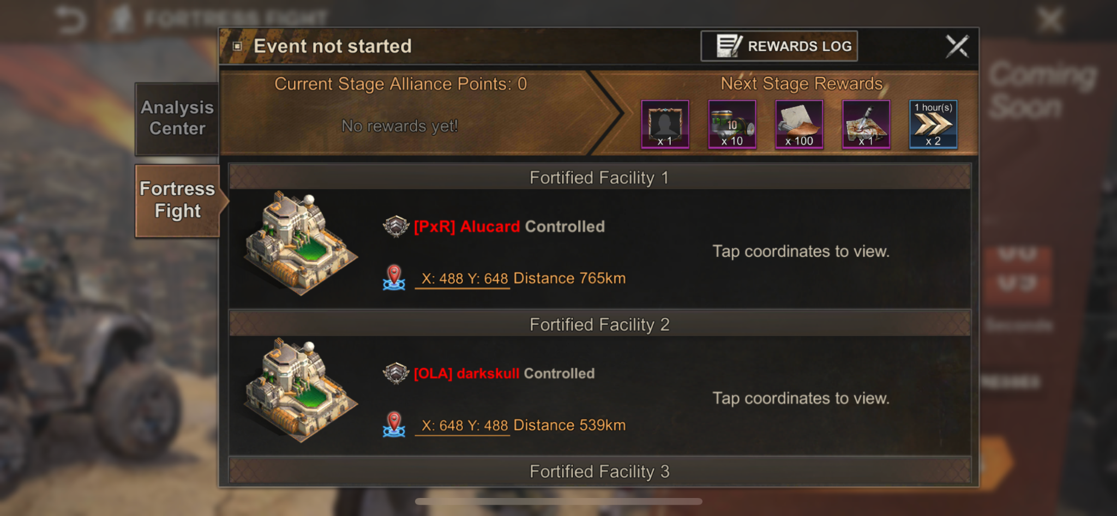
- Season End:
  - 8 rounds per Season
  - Mini Wonder is weekly but not every week
  - No clear rule on which week are mini wonder and which aren’t (most likely a break week at the end of season)
  - Week of season players are currently on located here:

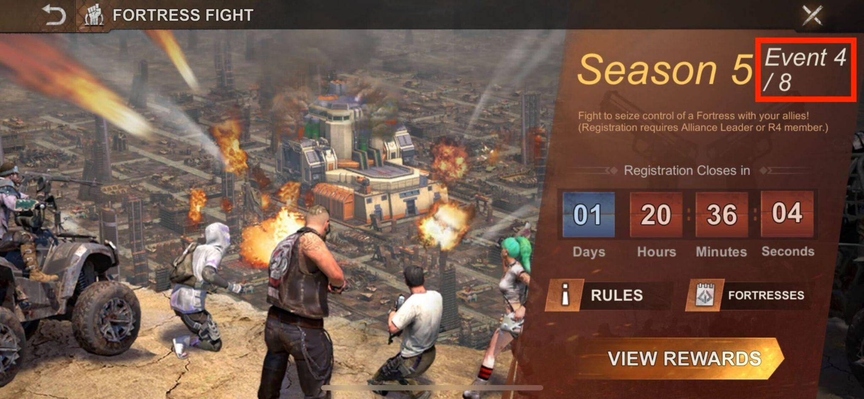

- Season Rewards are listed further down

Mini Wonder Map
https://docs.google.com/spreadsheets/d/1EGdGXoiLCRXkihIcAAH89oXH8WN0-V0r07lmbmgSReI/edit#gid=709027019

Edge Cases
- If a Player leaves their Guild during the event they forfeit their rewards.
- If a Player join a Guild while a Season is currently running, the Player doesn’t receive rewards.
- Disbanding a Guild needs to be considered, but should be allowed.

Rewards
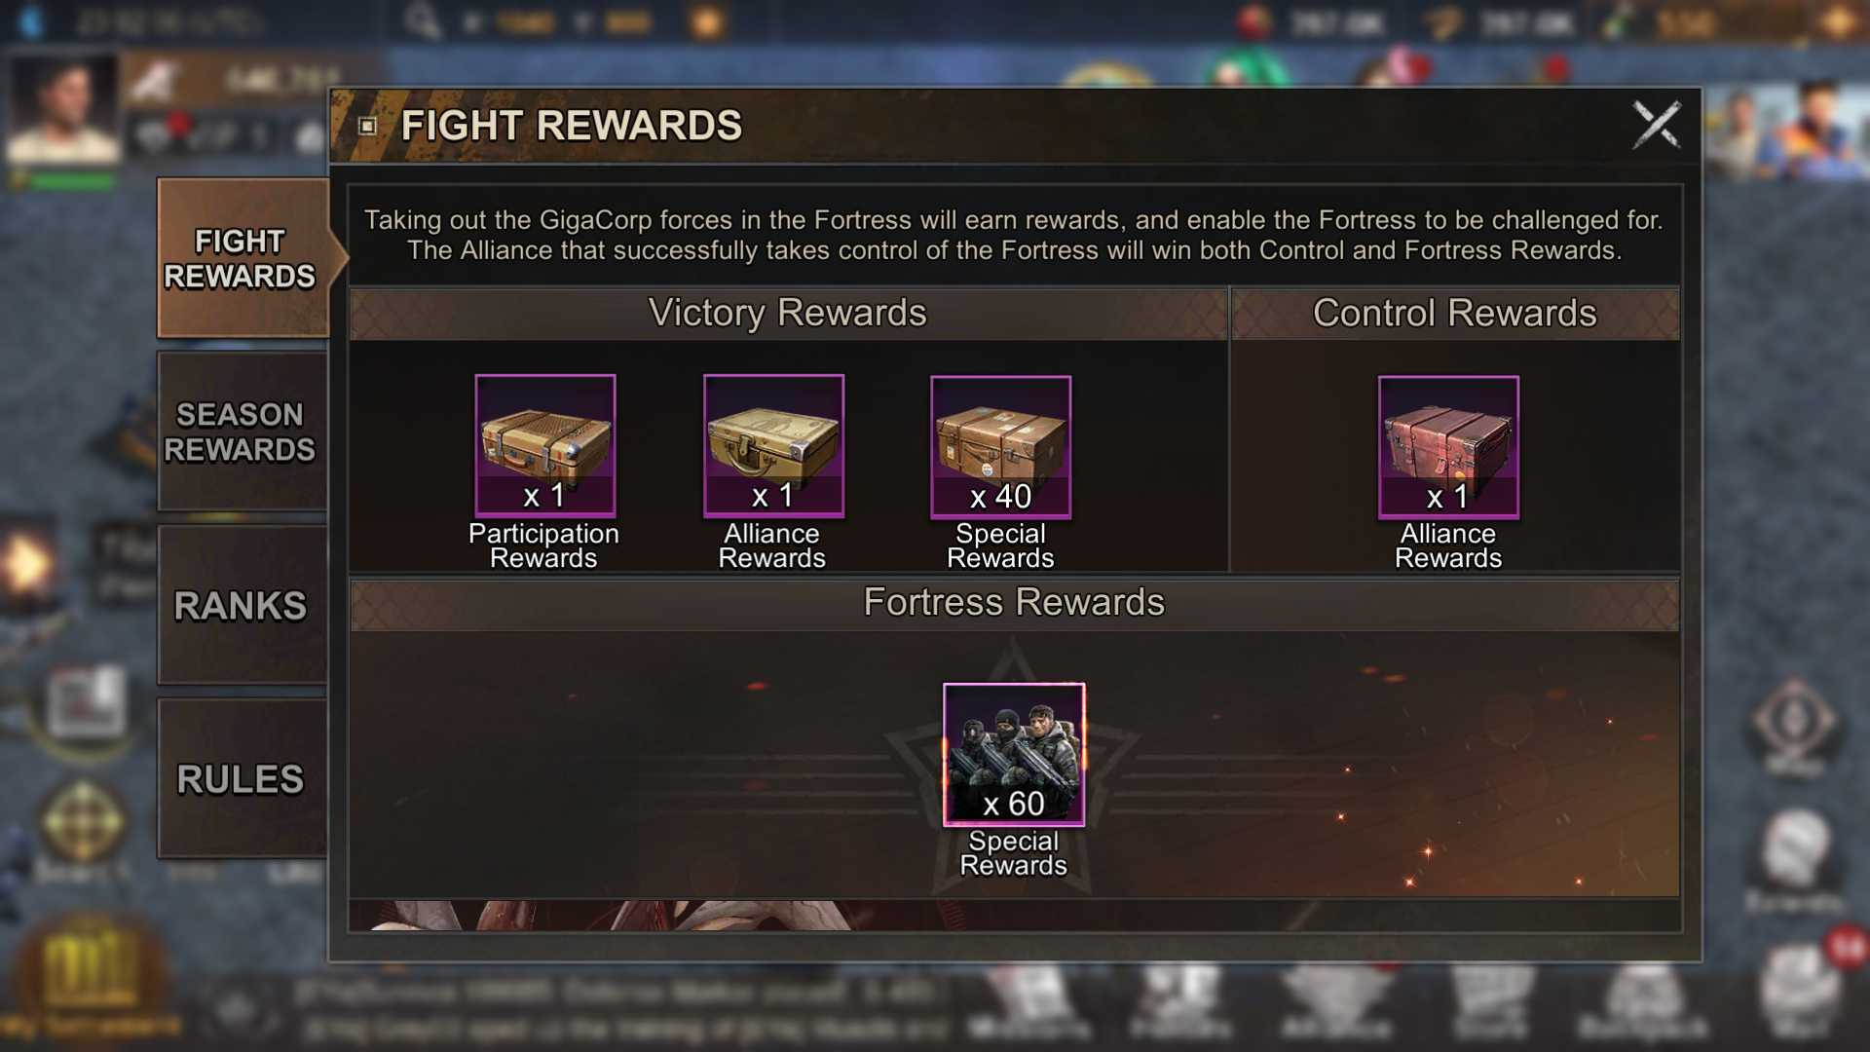
- Guilds can receive the following rewards for meeting the listed criteria:
  - Niflheim Rewards: All members who participated by sending at least 1 troop in the attack which defeats the PVE defenders receive:
    - Minor Stronghold: 1x Conqueror's Chest
    - Major Stronghold: 2x Conqueror's Chest
  - Defender Rewards: All members of the guild who were reinforcing the mini-wonder at the moment of victory receive:
    - Minor Stronghold: 1x Defender’s Chest
    - Major Stronghold: 2x Defender’s Chest
  - Special Rewards: Upon claiming control and for a period of 24h the R4 and R5 members can distribute:
    - Minor Stronghold: 40x Honor Chest
    - Major Stronghold: 100x Honor Chest
  - Control Reward: Upon claiming control all members, regardless of participation, receive:
    - Minor Stronghold: 1x Control Chest
    - Major Stronghold: 2x Control Chest
  - Unique Reward: Upon claiming control and for a period of 24h the R4 and R5 members can distribute one of the following possible rewards based on the specific fortress or stronghold:
    - Minor Stronghold rewards:
      - 90x Advanced Teleports
      - 200x Hero Shards
      - 400x 1 hour speedup
      - 300x 10,000 Hero XP
      - Combat Buffs:
        - 60x Troop Lethality boosts (12h)
        - 60x Troop Health boosts (12h)
        - 60x Mega March Capacity boosts (8h)
      - These rewards rotate round robin around each of the 12 Fortresses
    - Major Stronghold rewards:
      - 504x Signature Item Material - hero gear material crate
      - 420x Hero Shards
      - 120x advanced teleports
      - 180x march speed up crates
        - 25% chance march accelerator 2 (50% remaining march time reduction)
        - 75% chance march accelerator 1 (25% remaining march time reduction)
      - 1 reward for each of the 4 Strongholds
    - These Rewards are distributed by the guild leader or R4. After the event, the

Crate Contents:

First Occupant Crate | Occupation Crate
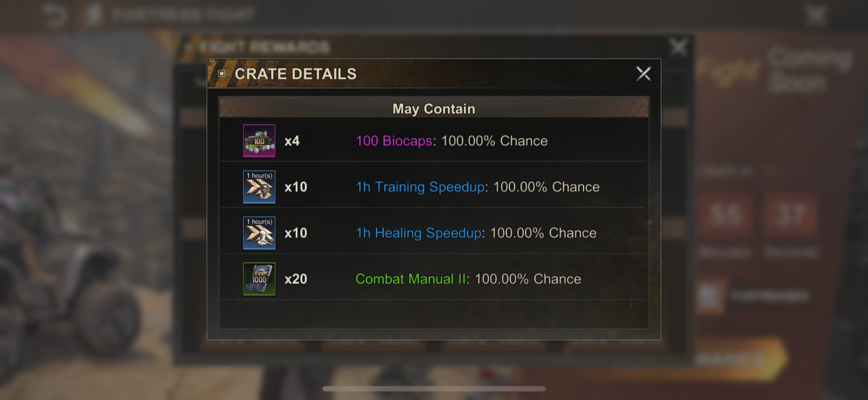 | 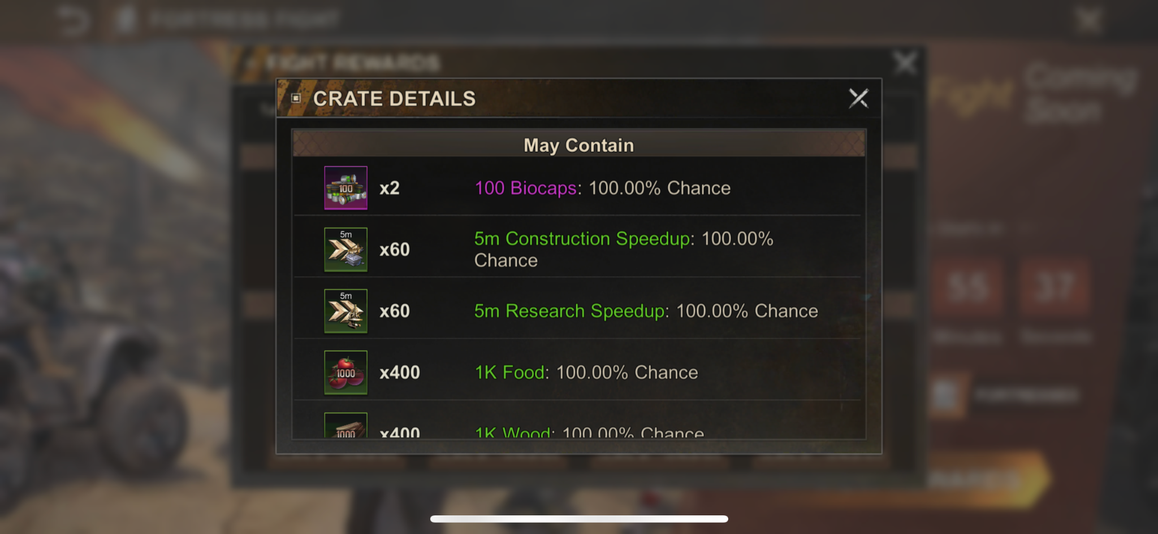

Warrior Crate | Control Crate
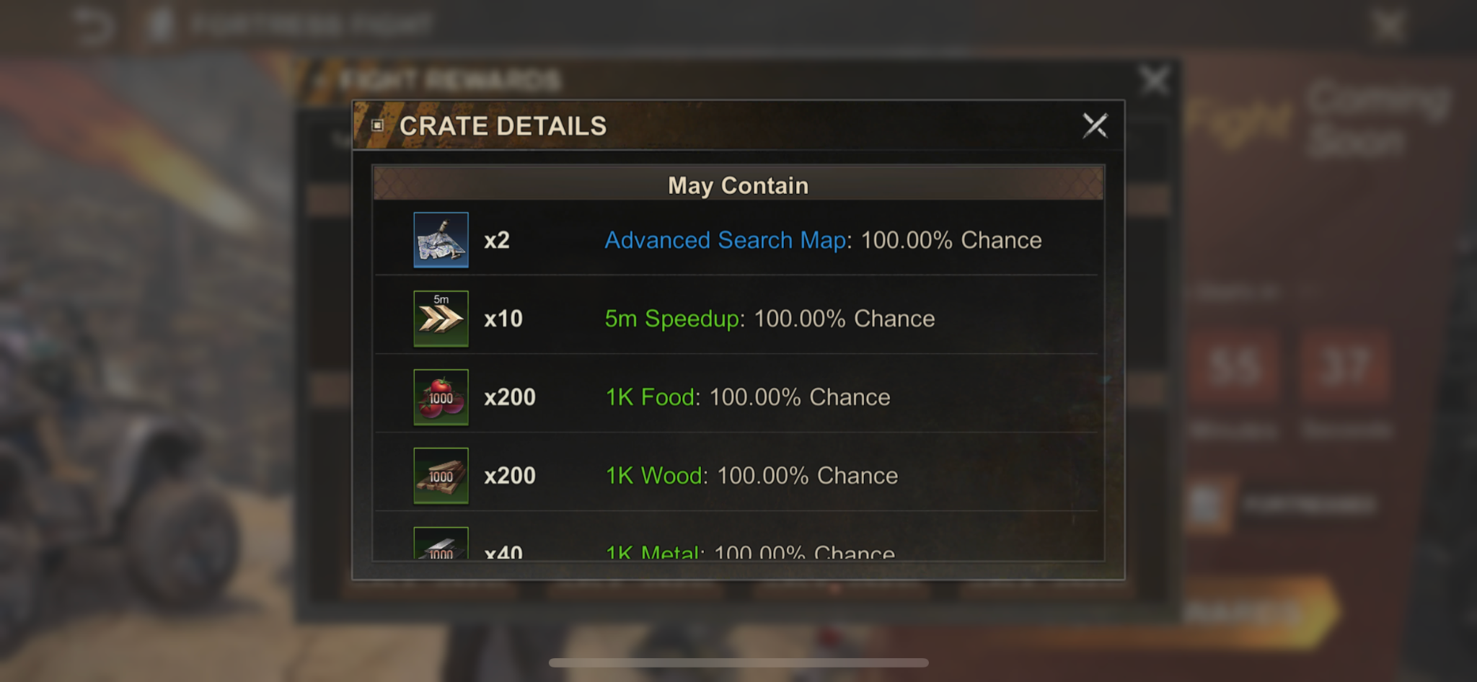 | 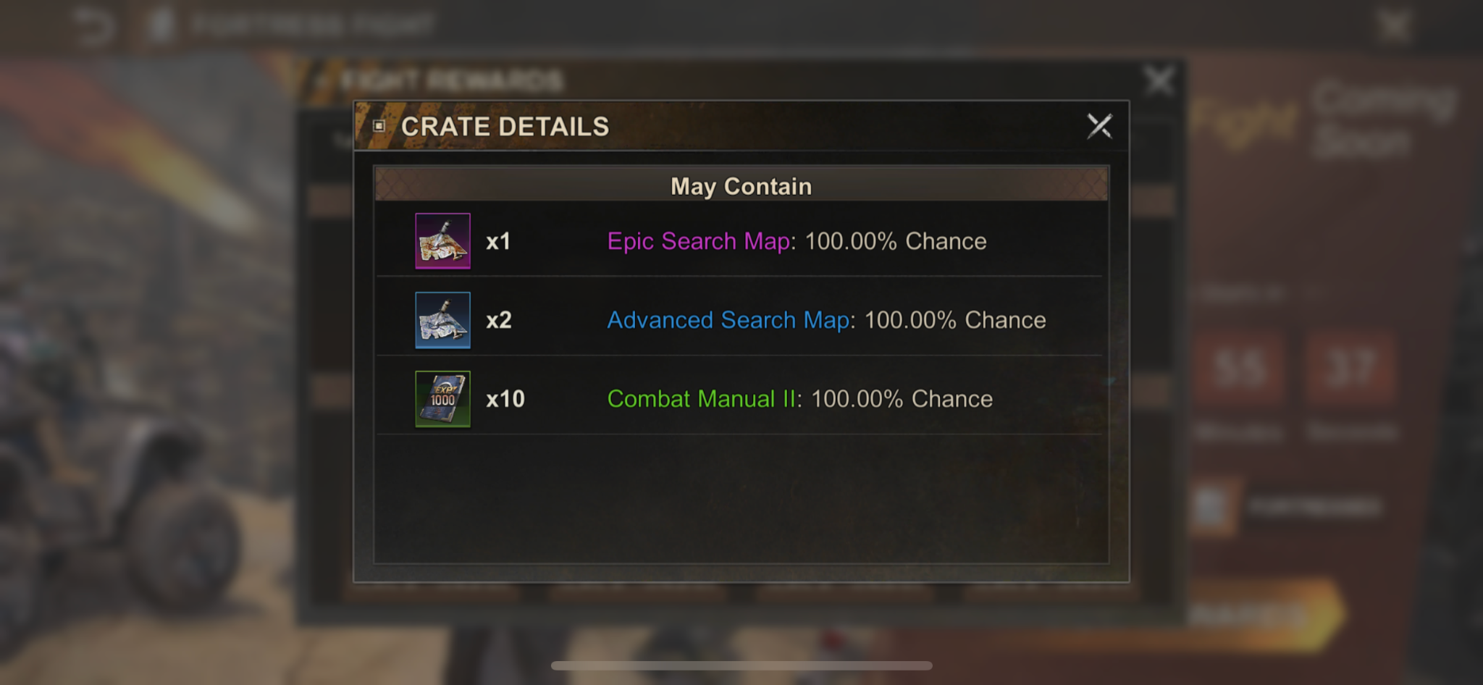

Season Rewards:
- Players receive rewards at the end of the season based on their guilds total score. Everyone in the guild receives the same rewards. The reward is based on the highest point bracket the Guild qualifies for.
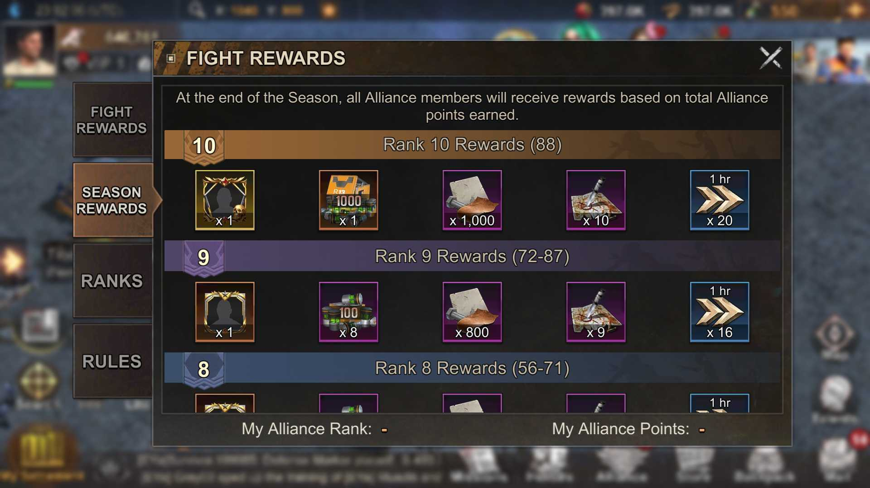
  - Series Rewards

Realm Advancement
- Realm Advancement contains two mini wonder related steps:
  - Bunker Discovery - Alliance must occupy a Fortified Bunker before the countdown ends
  - Twist of Fate - Alliance must occupy a Fortified Facility before the countdown ends
- These two realm advancement steps are both instances of mini wonder that occur outside of the regularly scheduled series.
  - They both trigger when their specific realm advancement step starts. This could be on any day of the week and is not fixed to the Wed->Fri schedule that the mini wonder series is on.
  - They follow the same three day structure as mini wonder series versions do: Notification day-> Registration day-> Fight day
  - The Bunker Discovery step ONLY has the 12 small wonders, not the 4 mid sized wonders.
  - They do NOT affect the series points but award all other mini wonder specific rewards as normal.
  - These two instances of mini wonder occur before the mini wonder series.
- What we need:
  - Scheduling a single instance of mini wonder outside of the normal seasons. Triggered based on some realm advancement trigger.
  - Creating a mini wonder event with only the 12 small wonders and not the 4 mid sized wonders.
    - Mid sized wonders stay in locked state
    - Mid sized wonders don’t allow registration
  - Remove series scoring for Bunker Discovery and Twist of Fate versions of mini wonder
  - No registration carry over from previous weeks like the registration system in the series. For example:
    - If you won a wonder in Bunker Discovery, you do not auto register for that wonder in Twist of Fate
    - If you won a wonder in Twist of Fate, you do not auto register for that wonder when the series starts
  - UI Changes:
    - Remove Series related tabs
    - Rename main landing pages removing headings relating to season/series

UI

Event Page
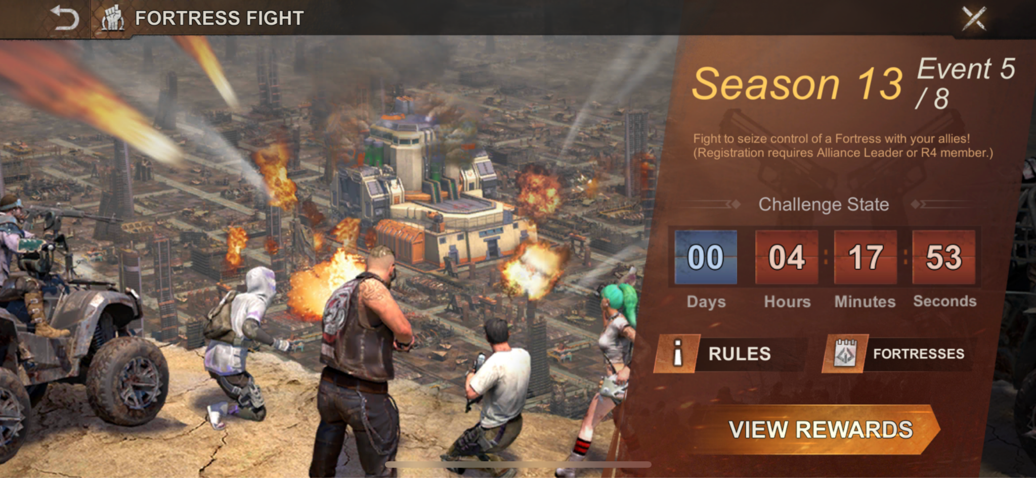
- Provides a button to access the Rules Page
- Provides a button to access the Fortresses Page
- Provides a countdown clock:
  - If not in the Season, countdown until it starts
  - If in the Season but the round hasn't started yet, Countdown until the day of battles.
  - If on the battle day, provide a countdown until the battle day ends.
- Provides a button to the Rewards Page

Rewards Page
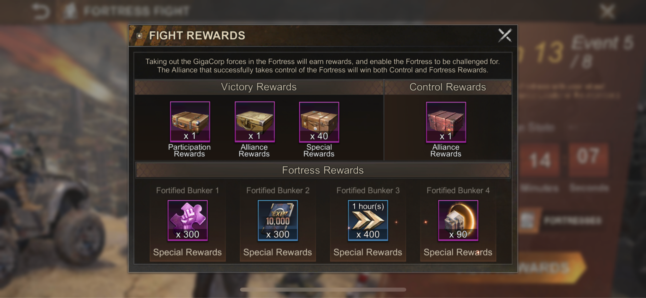
- Special version of the rewards tab of the information page that shows the special rewards for all the mini wonders in a vertically scrolling list.
  - Mini wonders are sorted 12 Fortresses then the 4 Strongholds.

Rules Page
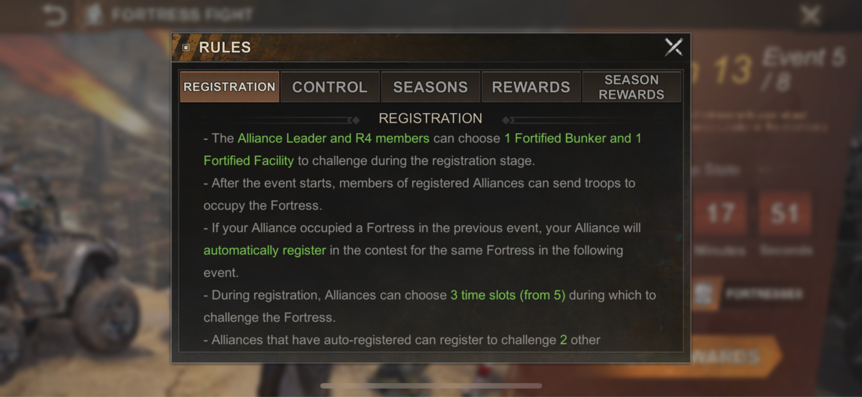
- Provides a popup with just the rule information tabs.

Registration
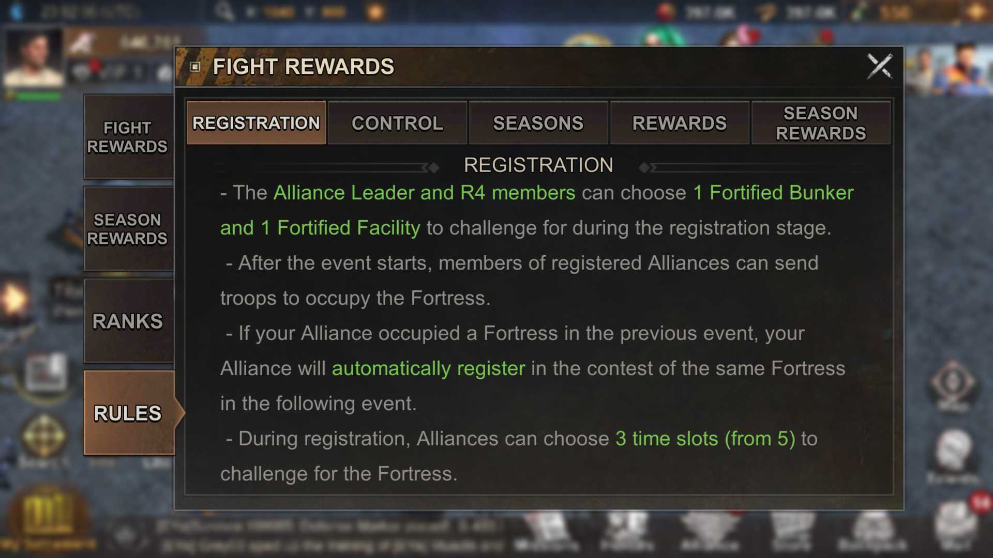
- Information on registering for a wonder.

Control
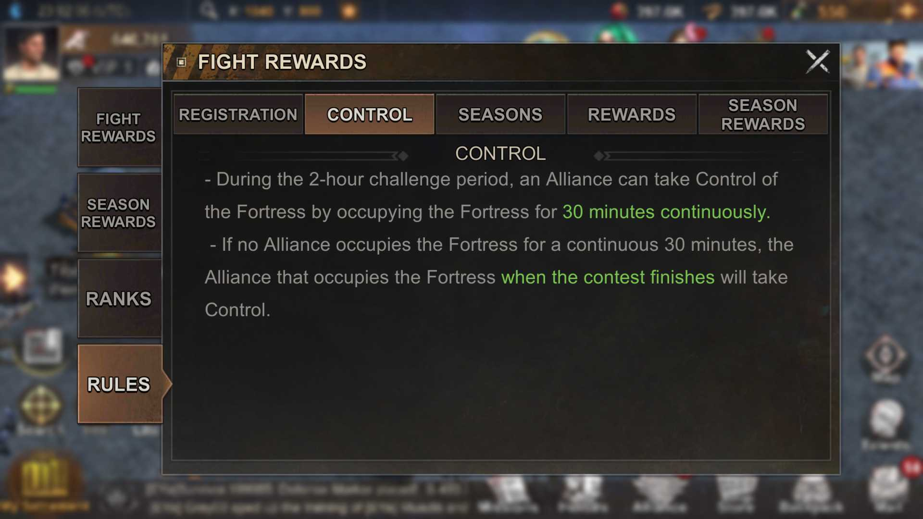
- Information for gaining control of the wonder.

Seasons
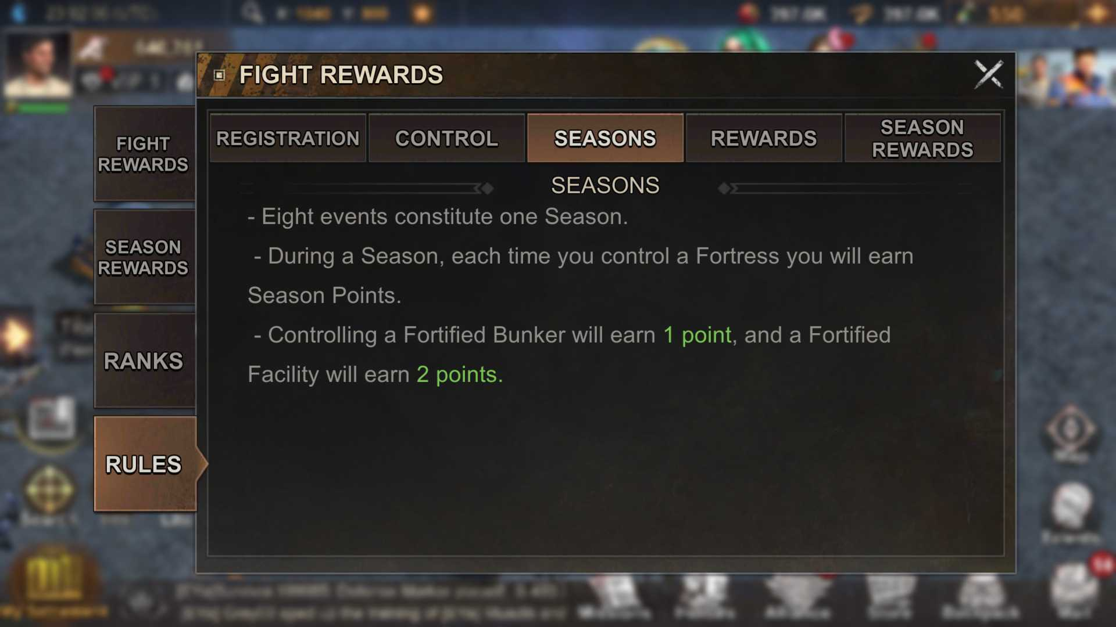
- Information about the season structure.

Rewards
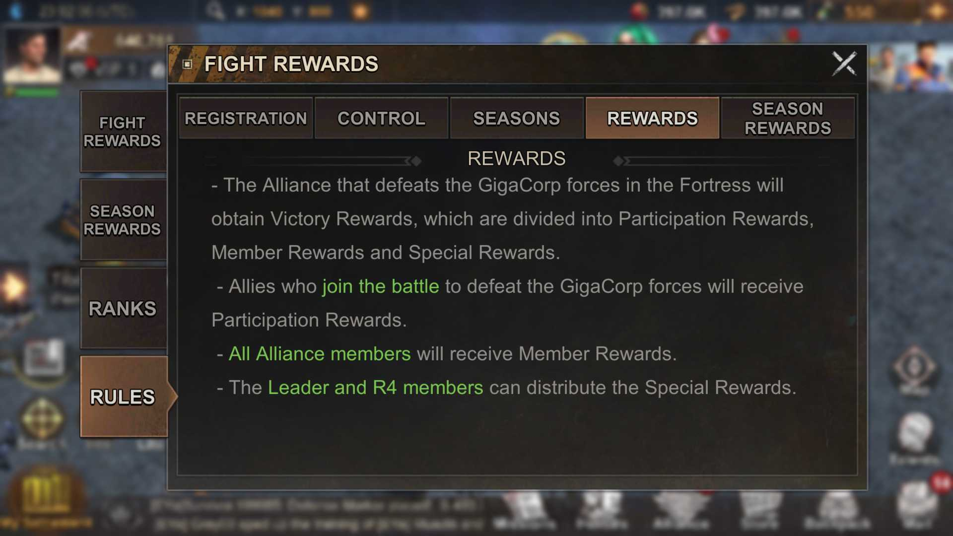
- Information about the different reward payouts that happen in season.

Season Rewards
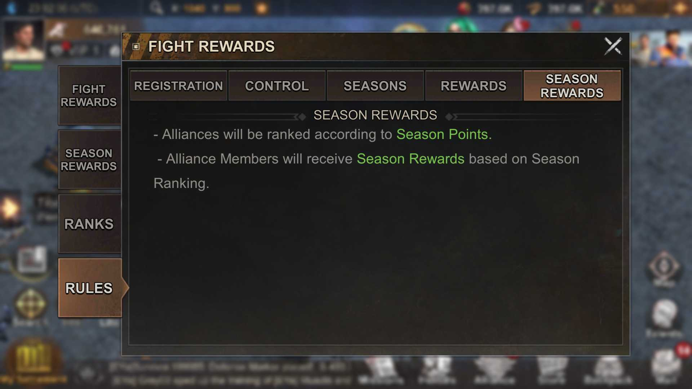
- Information about the end of season rewards.

Information Page

Access
- The primary rules and rewards summary can be found on any of the Mini Wonders and from the Mini Wonder event page.

Fight Rewards
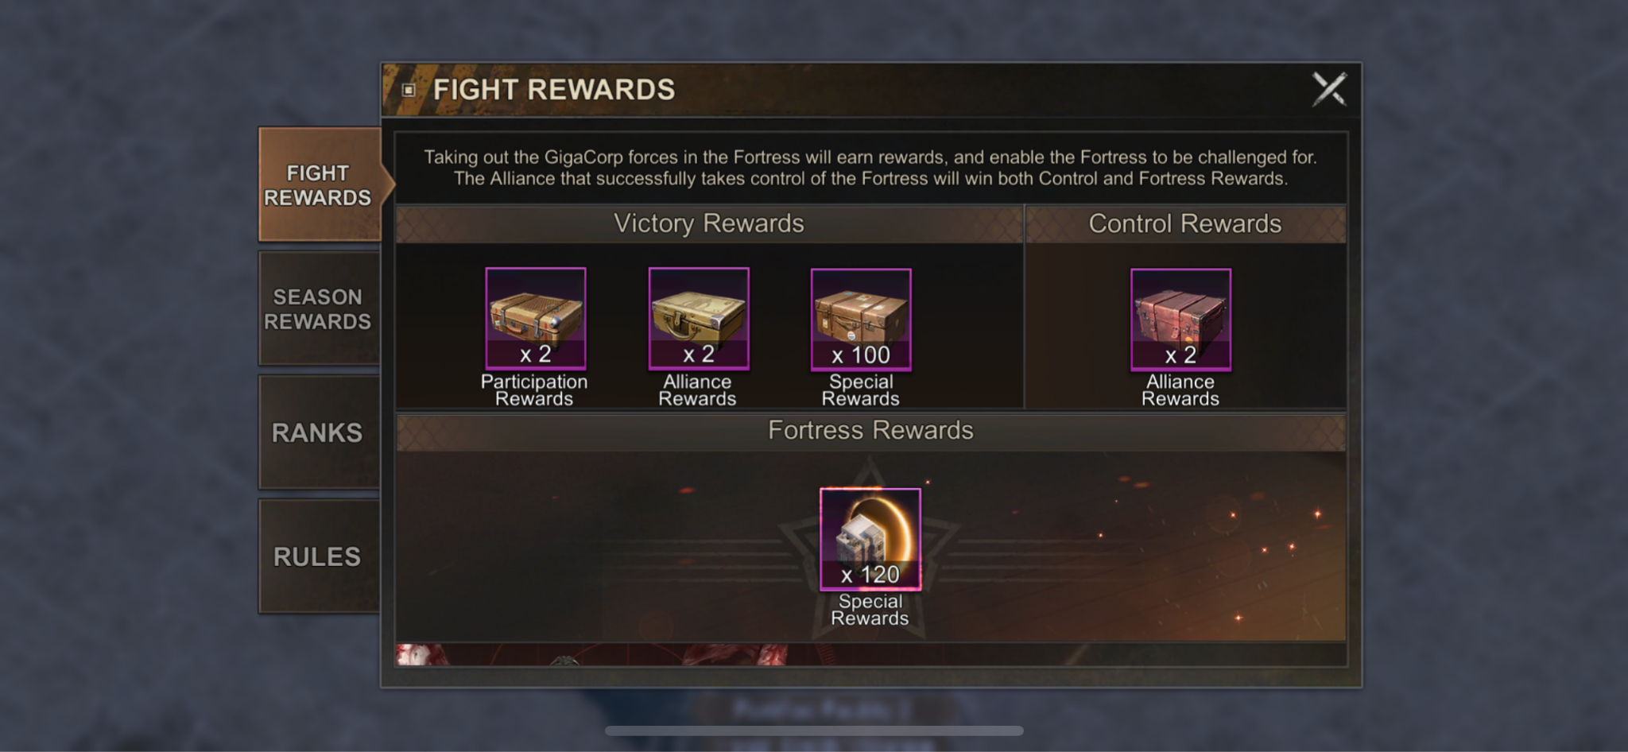
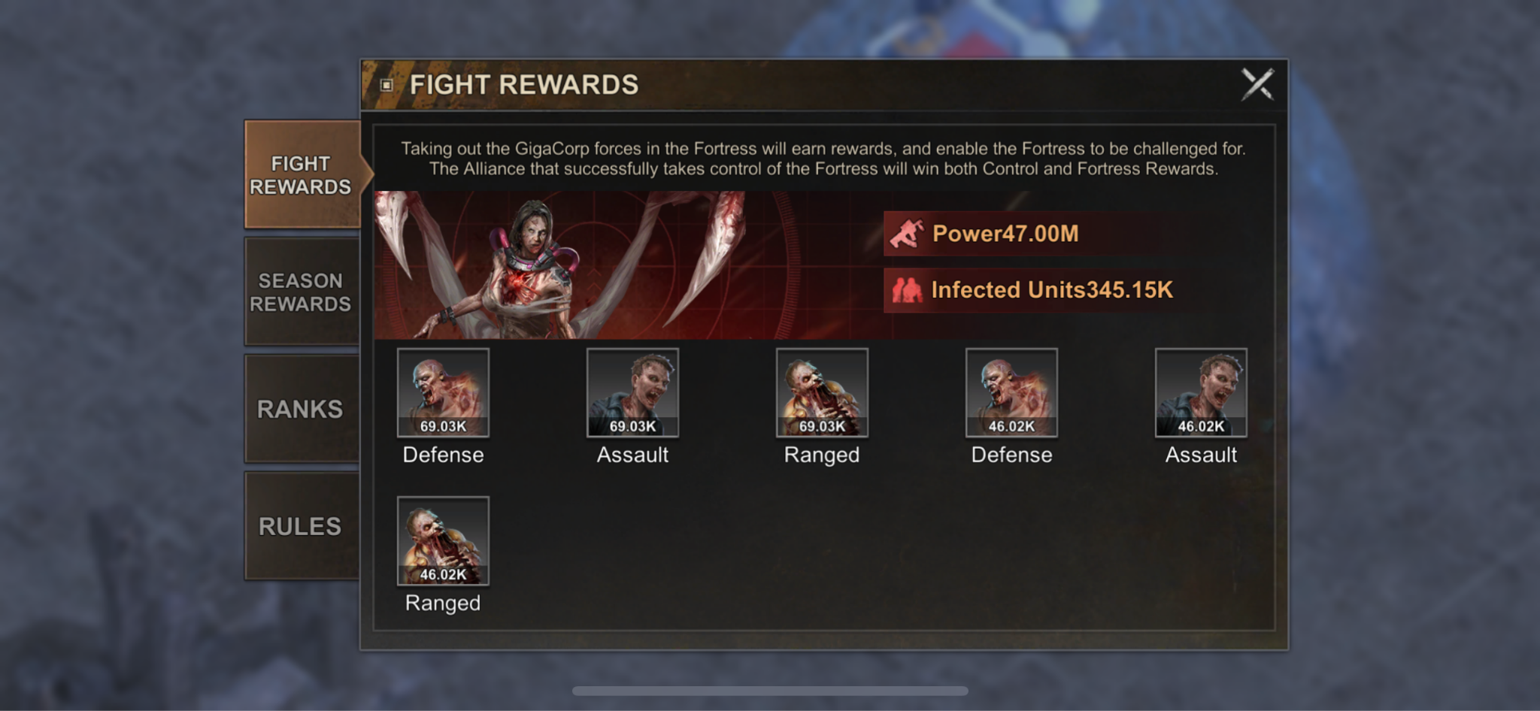
- Indicates the specific rewards for the selected wonder.
- If there is a PVE defender, indicates the PVE defenders strength.

Season Rewards
- Shows the ranks with the rewards listed in each.

Guild Ranking
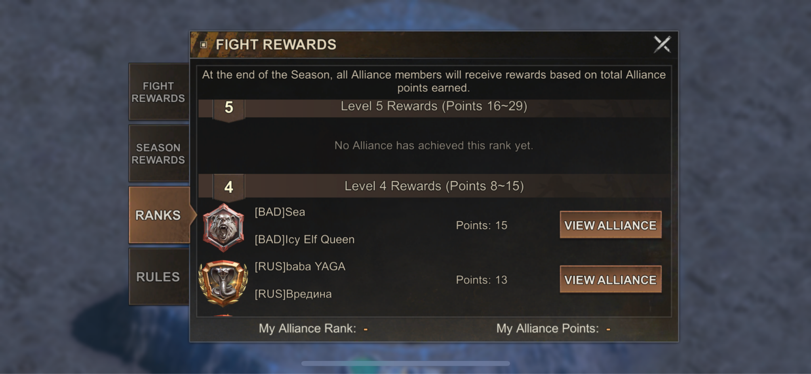
- The Guild Ranking page displays all the reward brackets and the guilds currently qualifying for the different ranks.
  - Guilds in these sections have a button to ‘view alliance’ which opens their Guild Profile.
  - Guilds display how many points they have so far in the season.

Rules
- Same as the normal rule page but backed into a tab here.

Fortresses Page
- Display the season and the week of the season
- Displays your guild's current points.
- Displays your guild's next rewards.
- Displays the fortresses in a sorted list
  - First sort: Registered vs not Registered
  - Second Sort: Fighting vs not fighting
  - Third Sort: Time until complete control
- Fortress rows display the:
  - State
    - Fighting
    - Controlled
      - If controlled, by who
  - Image
  - Name
  - Occupier
  - time until complete control
    - Only displayed when the state is fighting
  - Coordinates
    - Tapping the coordinates takes you to the mini wonder.
  - Distance
  - Special reward
- Rewards Log
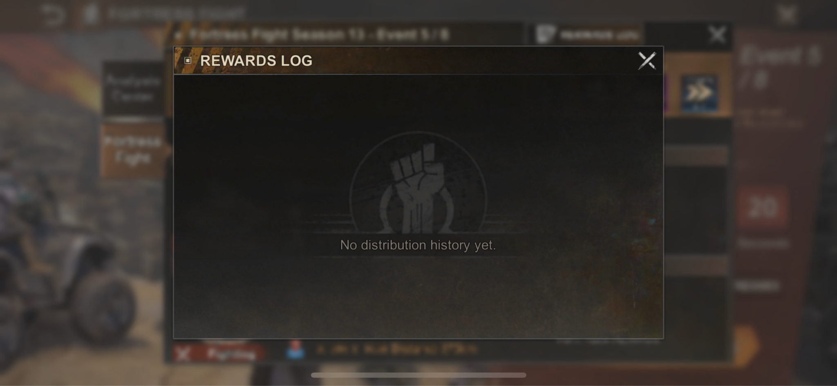
  - Provides a chronologically sorted list of the rewards you’ve distributed
    - Most recent rewards on top.

Radial Menu
- Pre Registration /off schedule
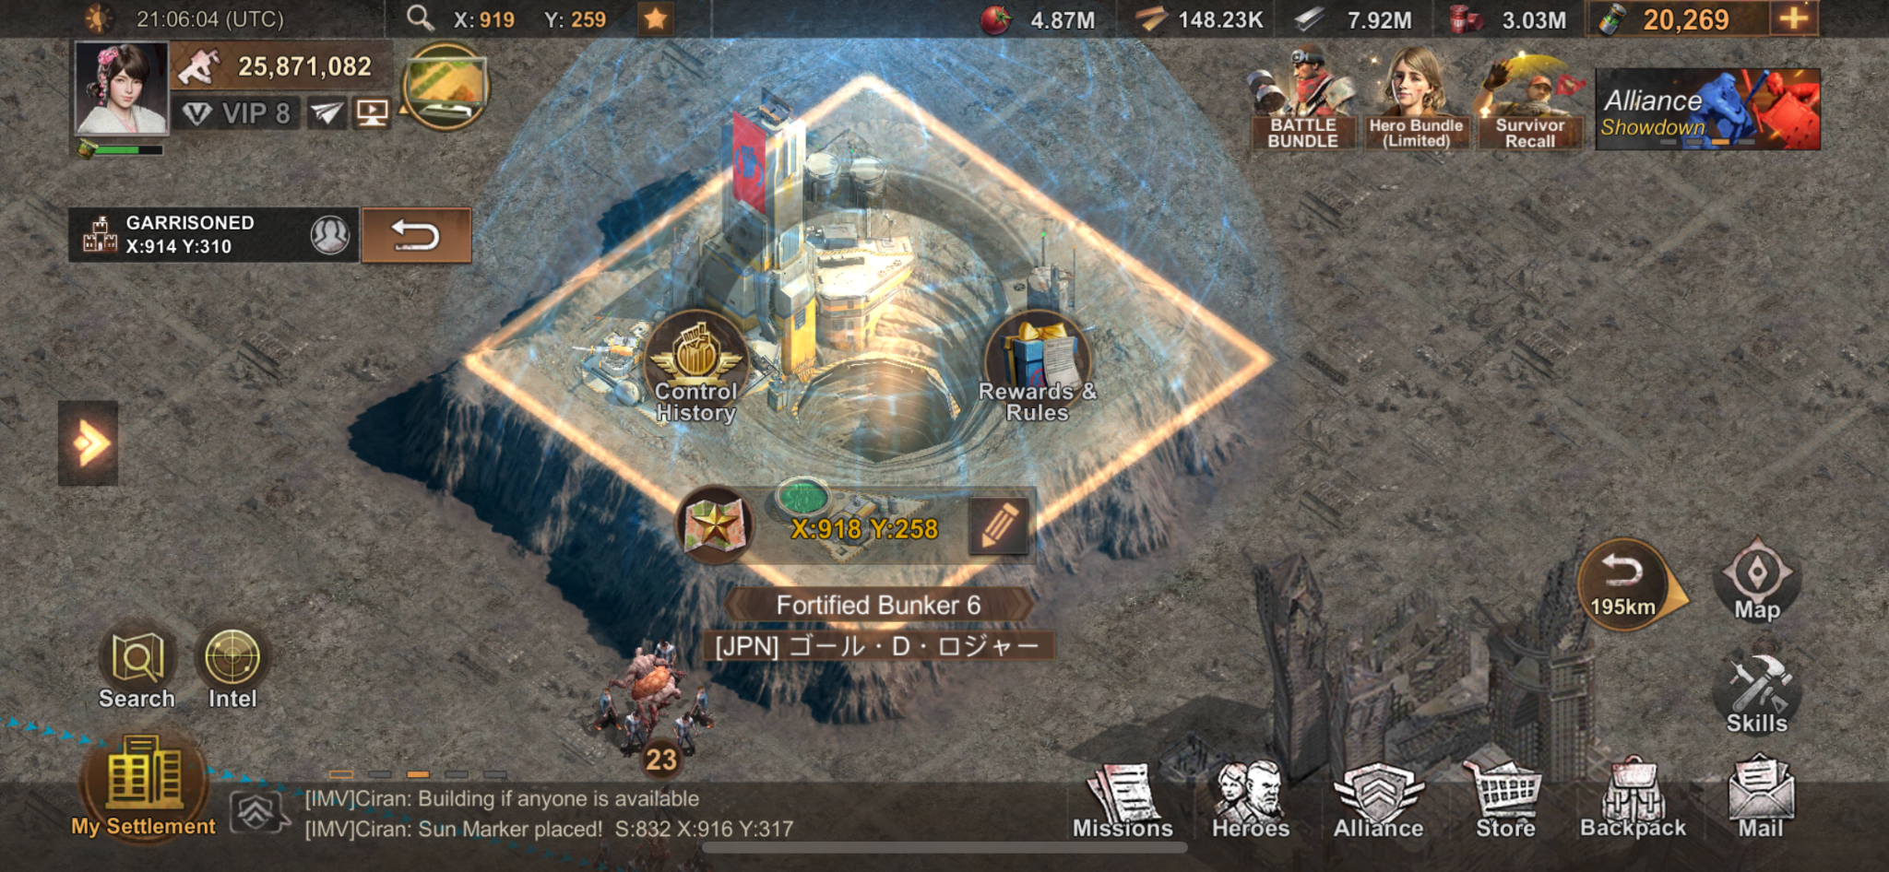
- Registration
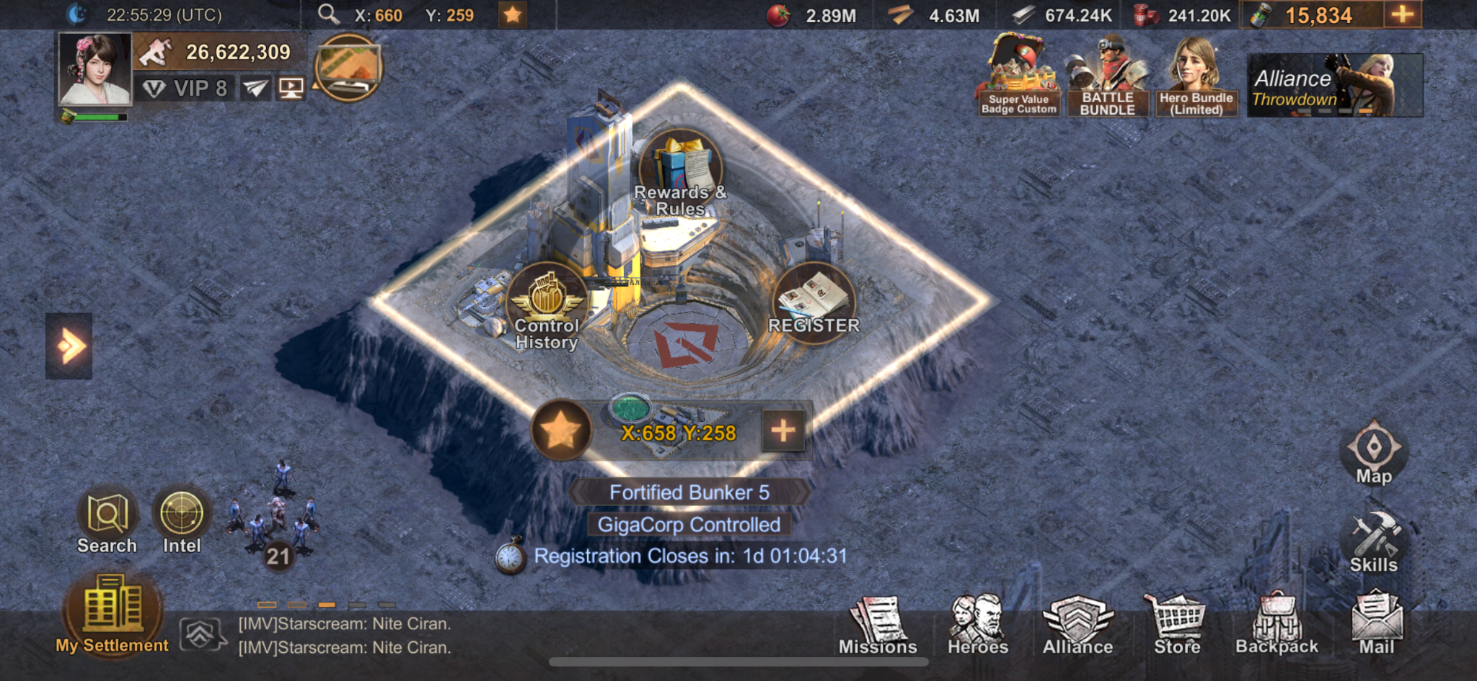
- Fighting
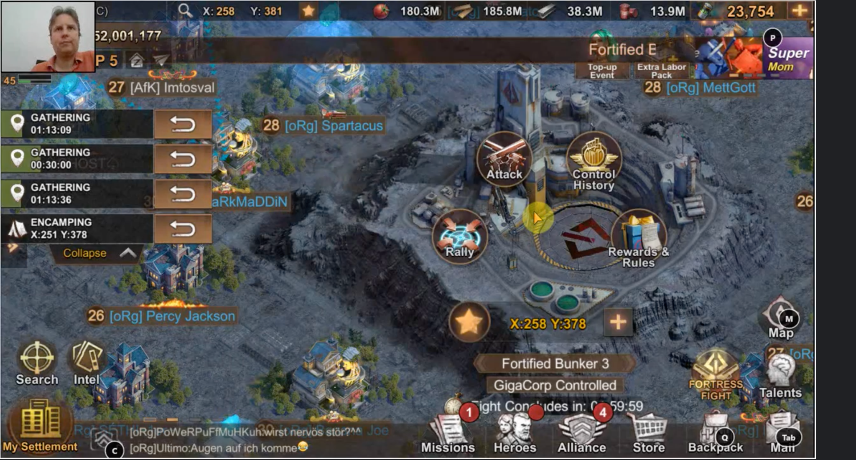
- You Control:
  - Recall
  - Reinforce
  - Control History
  - Rewards & Rules
- Ally Controls:
  - Reinforce
  - Control History
  - Rewards & Rules
- Enemy Controls:
  - Attack/Rally
  - Control History
  - Rewards & Rules
- All states of the radial menu have a coordinate option at the bottom that can be shared or favorited:
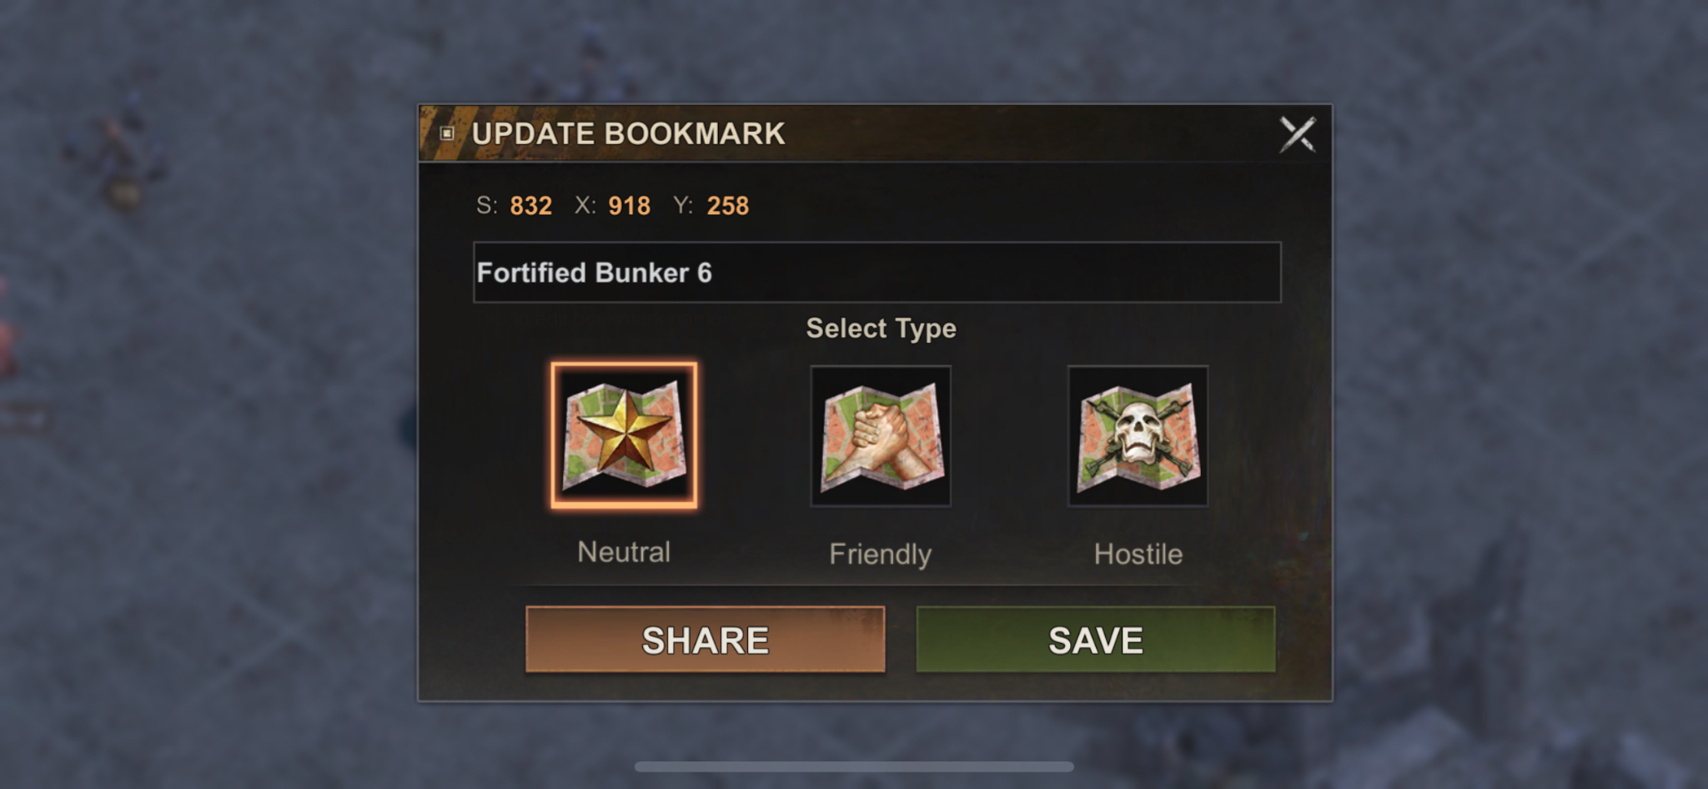
- Theses should be the same for both fortresses and strongholds
  - Control History
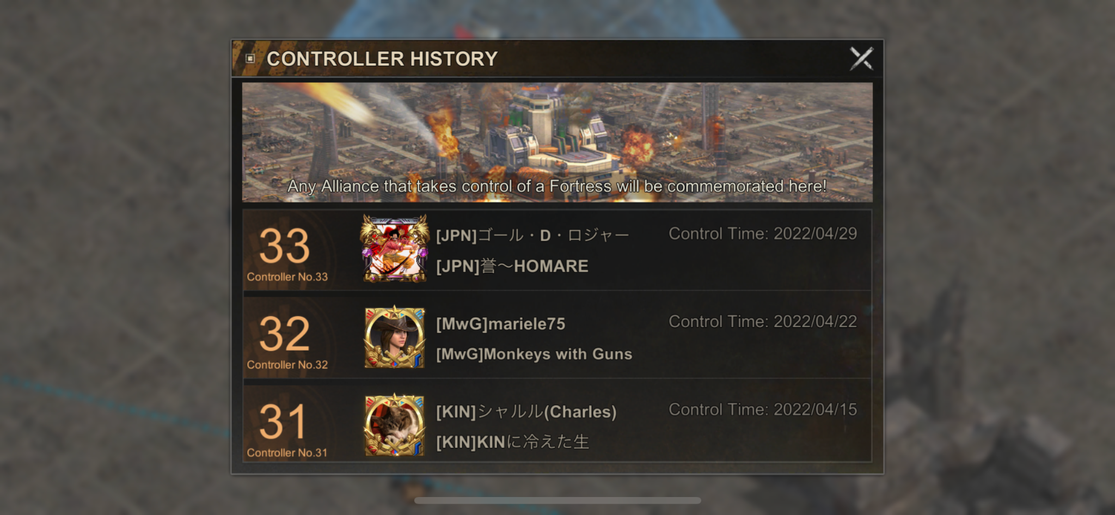
    - Shows each controller(winner) of this wonder since the start of the state
  - Rewards and Rules
  - Registration
    - Selecting time slots
    - Message when you do not have the guild rank to select a timeslot
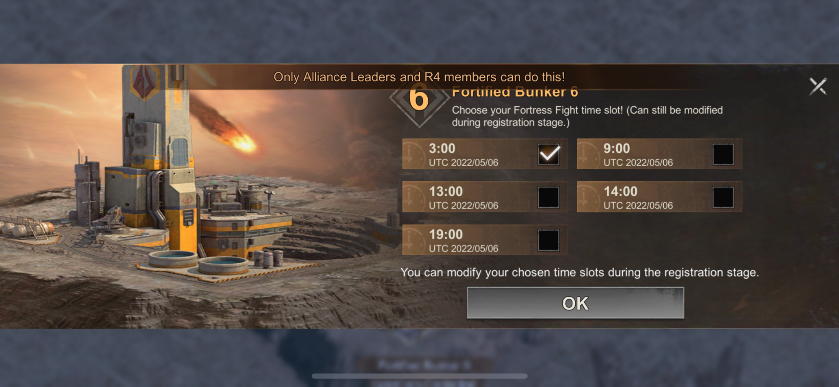

Sales
We will need custom sales for the mini wonder event:
- Pre Fight
  - Training Speedups
  - Combat Boosts
    - March Speed
    - March Size
    - Attack/Def
  - Event Triggers:
    - Notification phase starts
    - Registration phase starts
    - Fight phase starts
- During Fight
- Hospital Speedups
- Combat Boosts
  - March Speed
  - March Size
  - Attack/Def
- Event Triggers:
  - Players individual round starts
  - PVE Phase ends/PVP phase starts
  - Lose control of mini wonder
  - Lose fight trying to take mini wonder

Implementation Details

Push Notifications
- Event begins / ends
  - Toast sent to all guild members
- Control gained / lost
  - Toast sent to all guild members
- When does the notice of the event go out?
  - Notice is given via mail to guilds who register (whether manually or automatically). Unregistered users / guilds do not receive notification. The event banner is used to spread awareness of the registration opening.
- When does sign up start?
  - Registration opens one week prior to the event.
- When does sign up end?
  - Registration remains available until one day prior to the event.
- When does the event start?
  - We haven’t picked a day of the week yet, but I’d suggest a weekend day
- How long does the event go for?
  - Effectively 24 hours, though challenge periods are not back to back
- When are results posted and rewards distributed?
  - Event rewards are distributed immediately via mail upon the conclusion of the event. Seasonal rewards (if we decide to use them) are distributed immediately after the final event in the season.

Tutorial
- Basic tutorial

Mail
- Players will receive a mail notification when their guild is enrolled in a Mini Wonder prompting them to register for a time slot
- Players will also receive mail with rewards upon the completion of the event (the rewards are detailed above and depend upon the guild’s success)

BI
- Event Performance: How is the Mini Wonder running?
  - Are players signing up for the allotted Mini Wonder time slots?
    - # of alliances scheduled for mini wonder vs. # of “eligible” alliances(need to figure out what “eligible” means”
  - Are players/guilds killing the PVE in a timely manner losing an adequate amount of troops?
    - time from wonder open until first occupation by player
    - Units lost/wounded against mini wonder PVE
  - Is control moving back and forth between guilds enough?
    - # of turnovers during wonder period
  - Are these ending too early or dragging on too long?
    - Start/end times of wonder holds.
    - # of wonders ending in 30 minute timer
    - # of alliances fighting per wonder
  - Are players burning troops at an adequate enough speed?
    - Units lost/wounded against mini wonder after PVE
  - Is there a steady stream of players marching on the wonder continuously?
    - # of marches per wonder
  - Are players rallying those marches?
    - # of rallies per march
  - Are they using boosts/temp skins to enhance their performance in marches?
  - Utilization:
    - Heroes
    - Troop types
  - What % of the guild are participating?
  - Are players able to make the time slots/duration?
  - Can Guilds win with very little participation?
- KPIs: How is the Mini Wonder affecting player behavior?
  - Are players spending to replenish troops?
    - Packs with troop training speedup /medic speedup
    - troop training speedup /medic speedup utilization
  - Are they buying boosts/temp skins to enhance their performance in marches?
  - Are players upgrading their buildings and increasing their army size (using speed ups) to prepare for the event?
  - How is spend changing pre, during, and post the event:
    - Spend per user
    - Conversion
    - By Spend bucket (Sv30)
  - Existing BI
    - hold_wonder:
    - events:
    - - event:
    - event_id: 1796
    - routing_key: controller.action
    - properties:
    - alliaid: _Guild_id #bigint
    - allianame: _Guild_name #varchar
    - control_time: _control_time #bigint uint32
    - curprov: _kingdom #int
    - end_time: _end_time #bigint uint32
    - homeprov: _home_province_id #int
    - next_user_id: _next_user_id #bigint
    - prev_user_id: _user_id #bigint
    - start_time: _start_time #bigint uint32

Performance
- Combat needs to be smooth even with many participants.

Art
- Document for art states of each wonder type from Main to Medium to Mini
  - https://docs.google.com/presentation/d/1qrp1f-ApyCK0qHqOlmnA6jIBqdFUC8at9kXBqfZHvgo/edit#slide=id.g7bc6b57097_0_237
- Icons Needed for rewards:
  - Custom Chests/MCs:
    - Conqueror’s Chest
    - Defender’s Chest
    - Honor Chest
    - Control Chest
  - Custom Adornments:
    - Knight Frame
    - Elite Knight Frame
    - Epic Knight Frame
- PVE Banner Art
  - Minor Stronghold
  - Major Stronghold
- PVE Models
  - Minor Stronghold
  - Major Stronghold

Audio
- The audio design for the marches feature will apply here as well.
- Custom sound for battle-begin. Fanfare, etc.
- WBN to have localized different music/BGA in the vicinity of the Wonder.
- If we want to emphasize the importance of assaulting a Wonder-class target, we could perhaps use a different, more grandiose sound when the march against that target is initiated…

Design Data
- A new “Type” column should be added to the existing Wonders.csv allowing a designer to define wonder spawns as either main or Mini Wonders. This implementation allows all wonders to exist in the same sheet in data for organizational convenience.
- We will need new static data that allows design to define the rewards in each of five categories, likely require five or more columns in either the Wonder class or a new class, e.g. WonderRewards:
  - Participation (awarded to PVE attackers)
  - Alliance (awarded to wonder holders)
  - Control (awarded to all members)
  - Distributed (v2, a pool of rewards distributed by r4 and r5 winners)
    - Shared (players always get these)
    - Unique (one reward is unique to each of the 16 wonders, rotating every week)
      - This may require unique behavior
  - Rank (awarded based on Season performance)

Event Quest Hooks
Enumerate the quest hooks needed for any events or quest systems in the game. Identify any on-going support needed in future content releases.
- Kill/Wound/Lightly wound on Fortress
- Kill/Wound/Lightly wound on Stronghold
- Lose/Get wounded/lightly wounded on Fortress
- Lose/Get wounded/lightly wounded on Stronghold
- Control Fortress
- Control Stronghold

Go-Tos
Call out any go-to functionality required by this feature. If there is on-going support required, indicate it here as well.
- Go to wonders from coordinates in the Fortress list

Feature Gates
Identify any feature gates needed and what is expected when on/off.
- Ideally 1 main feature gate for this
  - MiniWonders

Live Ops
Functionality and expectations of live ops interacting with this feature should be indicated here.
- Need the Crystal(Wonder) tool from NISO to:
  - Manage vacate and protection of wonders
  - Look at wonder history to see how combat resolved

Debug Commands & Presets
Internal debug commands to help test the feature or avoid costly blocking of testing other features. If presets need to be applied to new users as well, we should indicate that here.
- Be able to change the current state of this event and modify the durations of the periods etc.

CS Tools
- Mini Wonder Admin Tooling Doc
- Event View Spec

Benching
Does this feature need to be benched by the server team? Developer of the feature should please indicate.

Internal Mini Wonder Informational Resources

MapObjectPlacement.xlsx (ffane)<- Wonder and Mini Wonder Footprints

Mini Wonder informational Resources
- https://state-of-survival.fandom.com/wiki/Fortress_Fight
- https://www.youtube.com/watch?v=nwjX8GiIxrg
- https://www.youtube.com/watch?v=_aWdHW4_vyg
- https://www.youtube.com/watch?v=lH8dCRNeROg

Outstanding Items
- How are series rewards distributed? Do they occur when each step is achieved or do you get 1 reward distribution at the end of the series based on the tier you reach?
- What system are we using for management of mini wonders in webapp? Can we use the crystal(wonder) system as it is more feature rich for mini wonders instead of the permanent object system?
- What are we doing with shrines? We need a more detailed spec and potentially a picture of if these are even related to mini wonders at all
- Maximum rewards that an be distributed per player for mini wonder rewards
- Event triggers needed for specific sales
- Do the adornments of the series rewards immediately trigger their expiration timer? Or does it only start the expiration timer when the user equips it.

